**Report on Applied Human Language Technology**

**Introduction**

The main purpose of this project was to design a natural simple language parser which was able to recognise a set of English sentences that was restricted using a lexicon and grammar rules. The system follows a recursive descent parser written in python which is supported by separate lexicon and grammar rule files.

1. **Lexical.txt:**

The first step of in terms of making the project was to establish the lexicon, the lexicon to me is my dictionary. In this file it describes every word my grammar will have with a POS tag, root form and number. It has vocabulary used by the parser.

Due to the lexicon being this structured, the parser can see the difference between singular and plural words leading to subject-verb agreement checking, it will also see the beginning of the extra features in prepositional phrases.It tells the parser what part of speech each word is, whether it is singular or plural

Each line equals one word and information with it, it follows the structure of word, POS tag, root form and number.   
An example of this is word, POS tag, root form, number = kings, NNS, king, pl

here is my code

the order I have my lexicon.txt file as word, POS, root number

Eg: queens NNS queen pl

queens is plural

POS is NNS (plural noun)

root word is queen

# Determiner (a modifying word that determines the kind of reference a noun or noun group has)

# for example a, the, every

the DT the sg # "the" is a determiner

a DT a sg # "a" is a determiner

# Singular nouns (A singular noun is a word that names one person, place, thing, or idea)

king NN king sg # "king" is a singular noun

cat NN cat sg # "cat" is a singular noun

castle NN castle sg # for PP sentences Eg: "in the castle"

# Plural nouns (A plural noun is a word that represents more than one person, place, thing, or idea)

kings NNS king pl # "kings" is a plural noun, root is "king"

# Adjective (An adjective is a word that describes or modifies a noun or pronoun, providing more information about its qualities, characteristics, or state)

new JJ new sg # "new" is an adjective

# Verbs (A verb is a word that describes an action, occurrence, or state of being)

like VB like pl

likes VBZ like sg

dislike VB dislike pl

dislikes VBZ dislike sg

# Prepositions (start PP)

with IN with sg # "with the king"

in IN in sg # "in the castle"

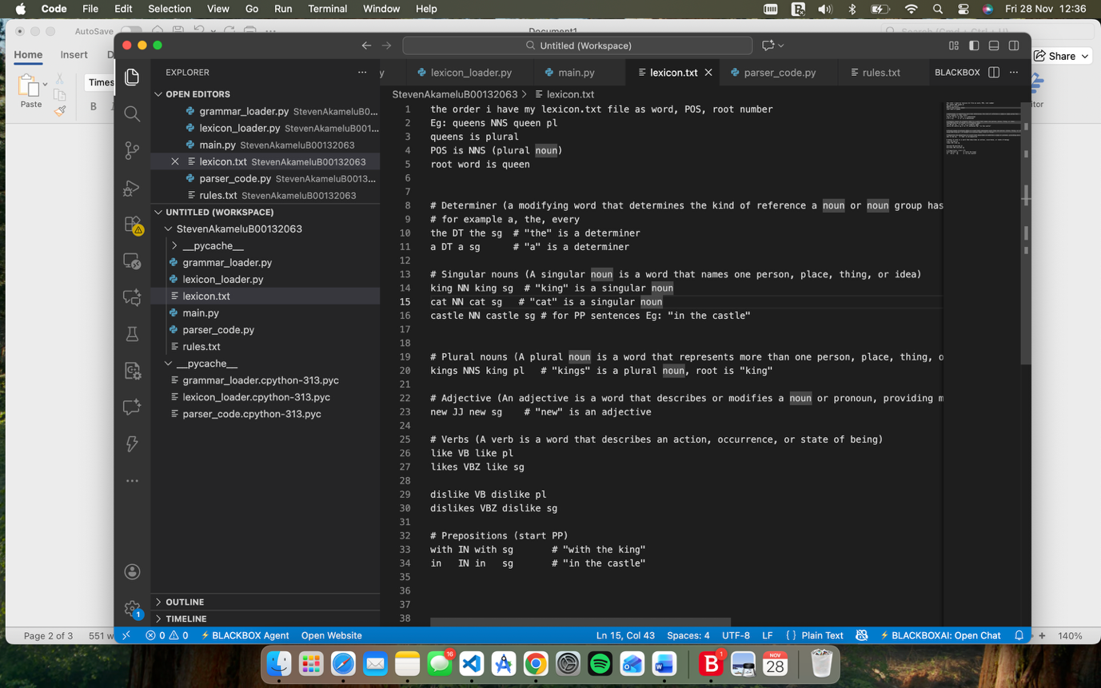

1. **Rules.txt:**

The rules.txt file is used to define the grammar. It defines the structure of sentences my parser will see and choose. This grammar uses and supports basic noun phrases, adjectives in a noun phrase, verb phrase with a direct object, verb phrases followed by prepositional phrases which was the extra feature I added so the grammar could extend.

First line = list of POS tags used

Next = grammar rules

Here is the code  
POS tags

DT NN NNS VB VBZ JJ

# Grammar rules

S -> NP VP

# Noun Phrase rules

NP -> DT NN

NP -> DT JJ NN

NP -> DT NNS

# Verb Phrase rules

VP -> VB NP

VP -> VBZ NP

VP -> VB NP PP

VP -> VBZ NP PP

# Prepositional Phrase rules

PP -> IN NP

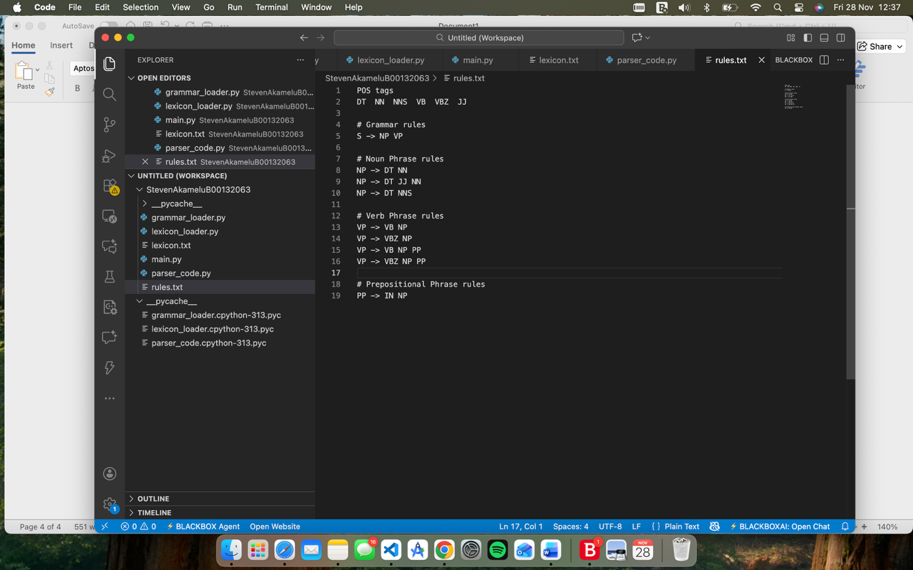

It tells the parser what a valid sentence looks like, how noun phrases are built, how verb phrases can potentially have prepositional phrases and once they are recognised how they can be built on.

1. **Lexicon_loader.py:**

The lexicon_loader.py file works as the dictionary reader for the system. If my lexicon.txt file is my dictionary things are loaded unto then the lexicon_loader.py will open the txt file and turn each line, I have into python object.

It defines the class for example LexiconEntry will store word, pos, root, number

It will then define the function load_lexicon(path="lexicon.txt") which opens the lexicon.txt file, loops through each individual line, while ignoring any blank lines, splits the word into 4 different section and stores each entry into the dictionary. This gives the parser an easy way to look up information about each word, if this file wasn’t here then the parser wouldn’t know what POS tag or number each word has.

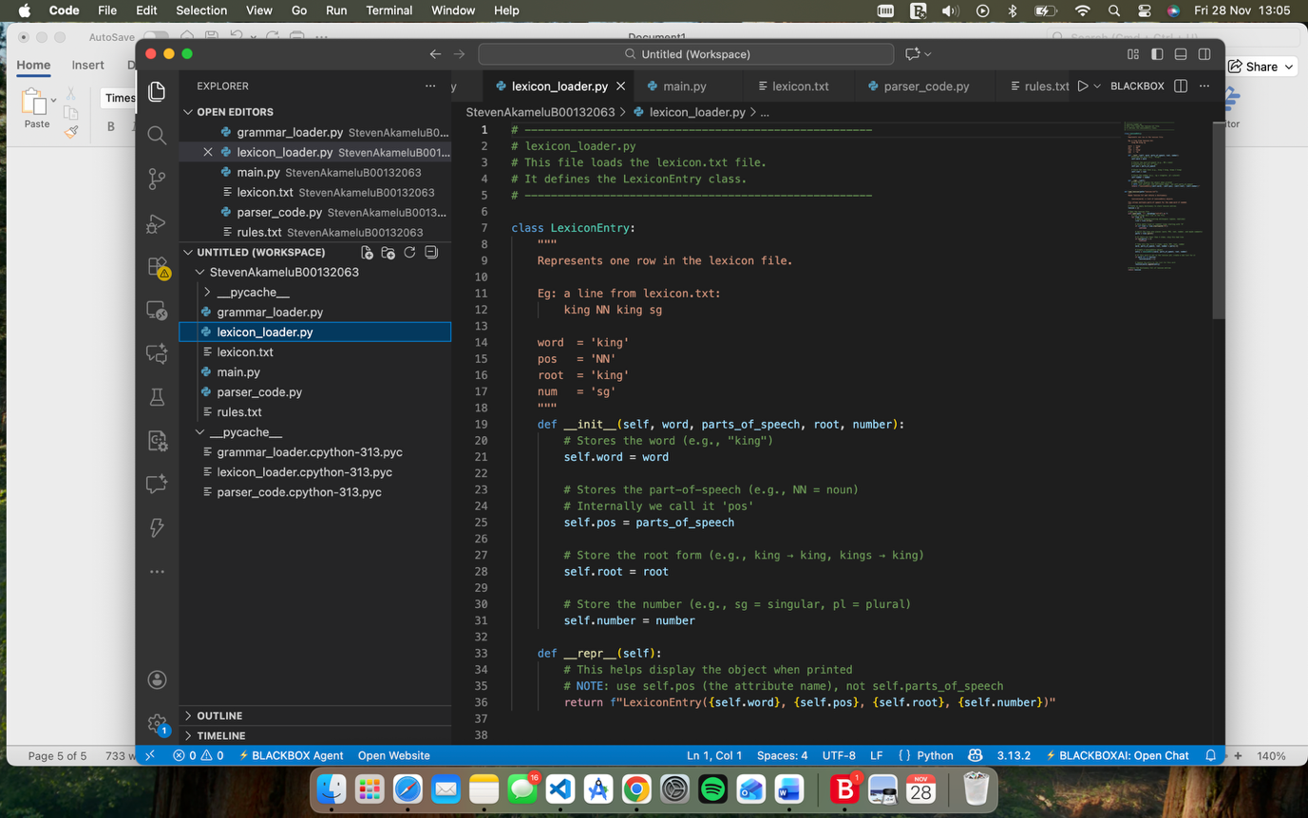

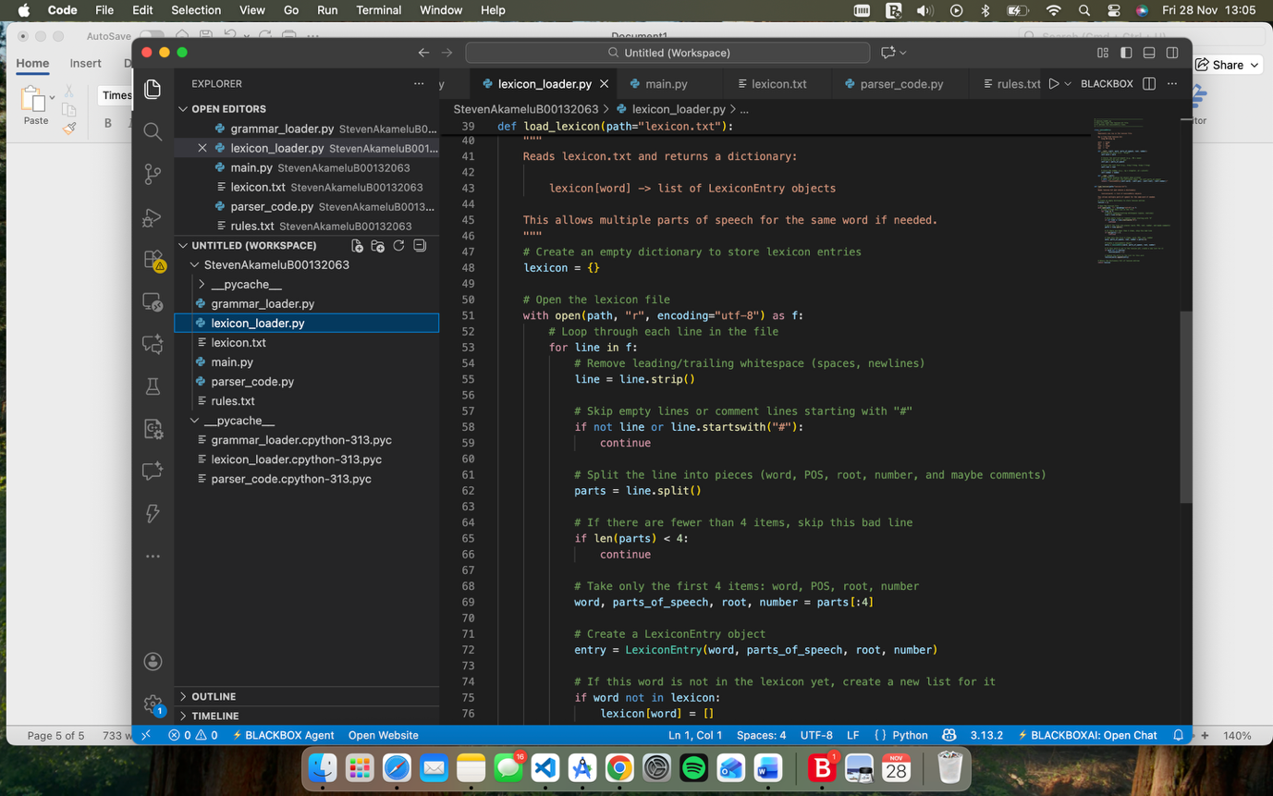

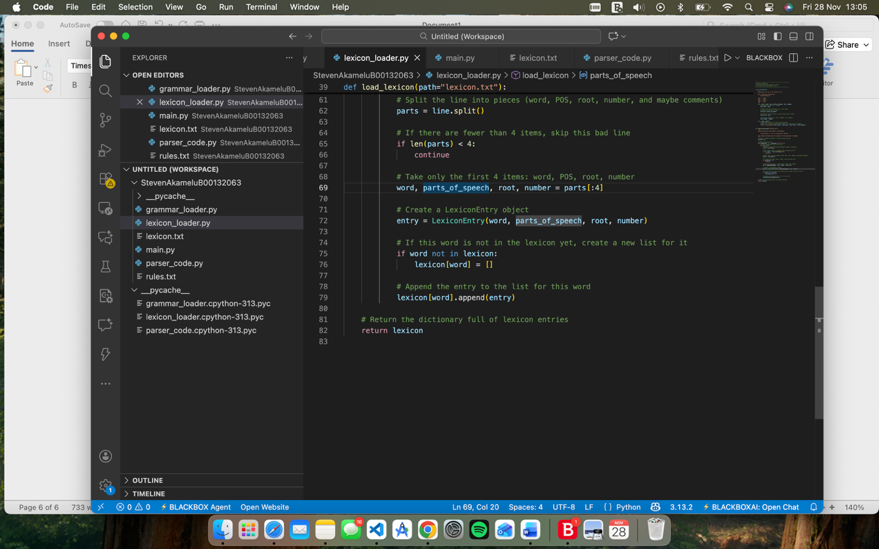

1. **Grammar_loader.py:**

Grammar_loader.py is my file that reads my grammar it will go into the rules.txt file and turn each line into structure that can be usable. It will read the first line and split into a list of Pos tags then it will read every line after that and it will be a Grammar Rule object eg: GrammarRule("NP", ["DT", "NN"]) then return pos_set, rules

This will give the parser knowledge about what pos tags can be used/will be accepted and how phrases should be built

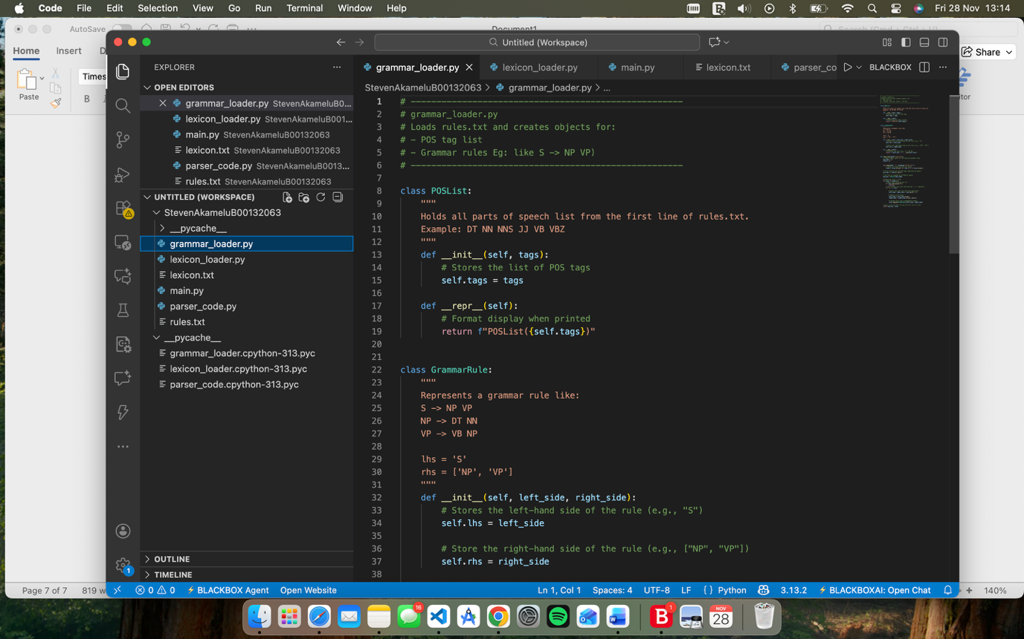

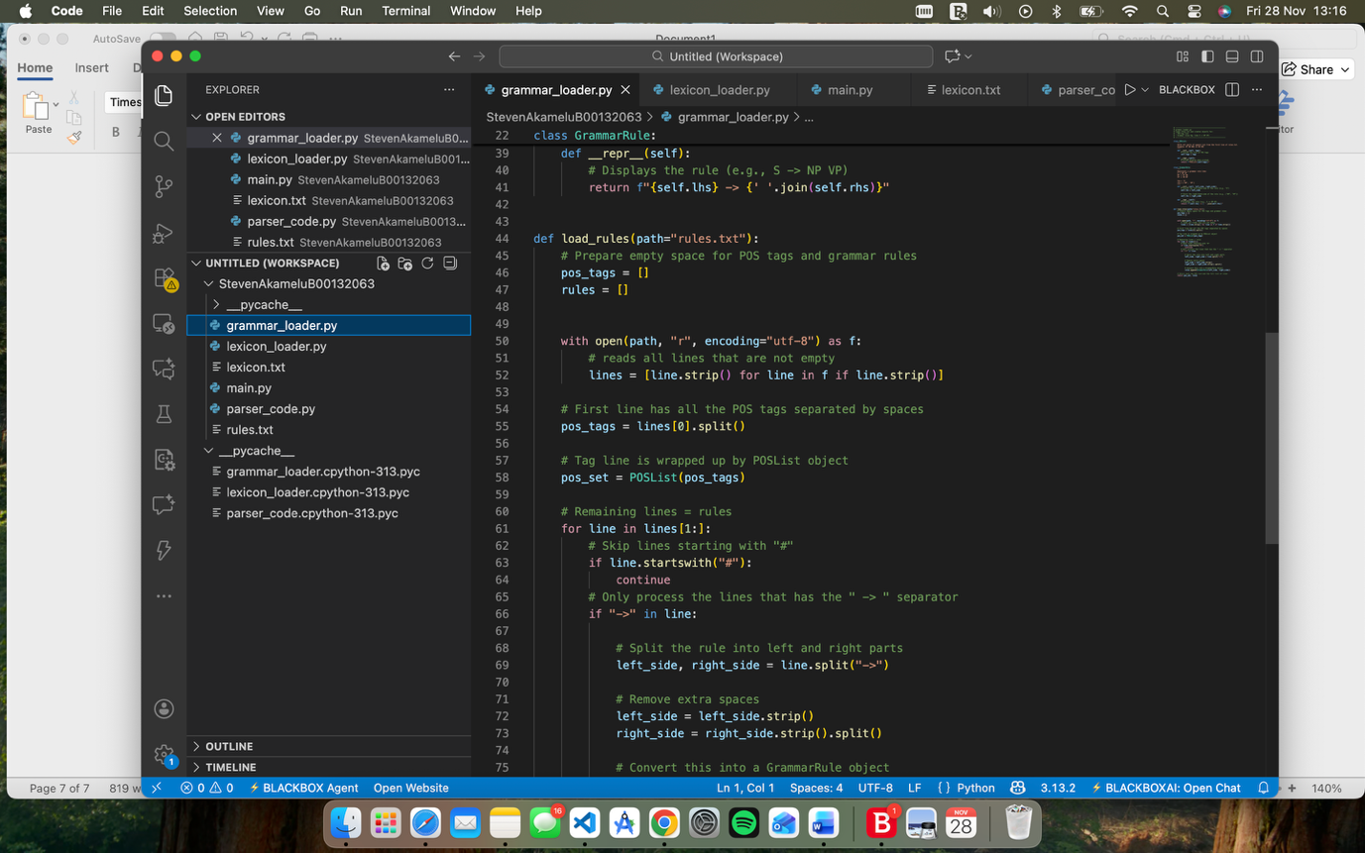

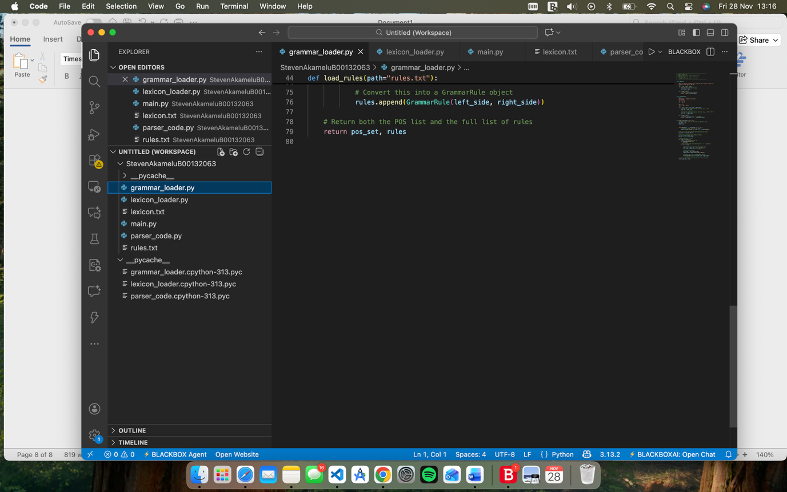

1. **Parser_code.py:**

In this file it will take a sentence and break it down into words also deemed as tokens. It follow the lexicon and grammar rules to decide if the sentence is valid, it will build a parse tree and will print an agreement warnings it may have.

It has a node class which represents a node in the parse tree whereas the parse class will hold the lexicon from the lexicon_loader, pos_set and rules from the grammar rules. This is where the parsing will take place. When it compiles it will say whether the following sentence has been accepted or rejected.

ACCEPTED: The sentence matches the grammar.

REJECTED: The sentence does NOT match the grammar.

Agreement warnings

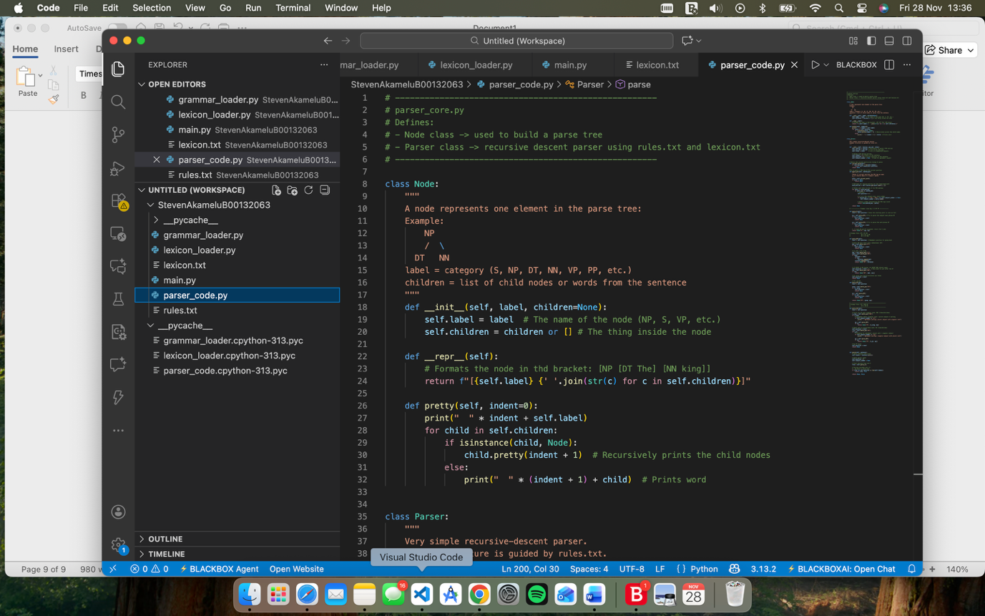

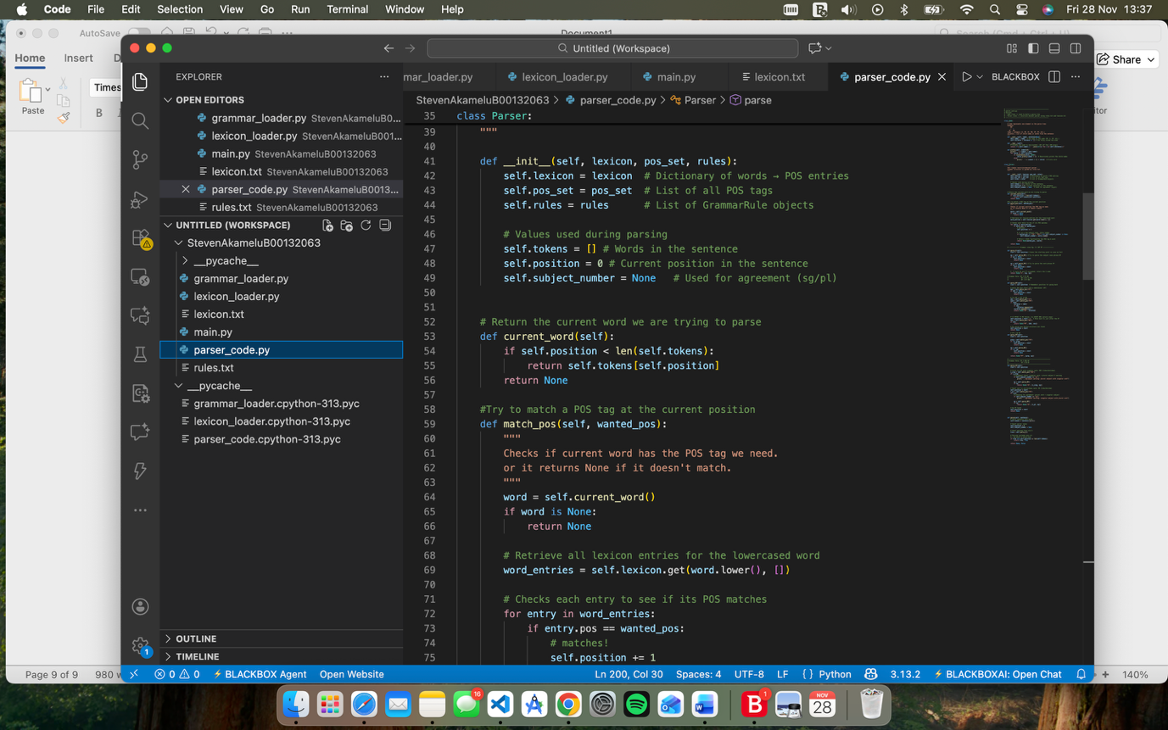

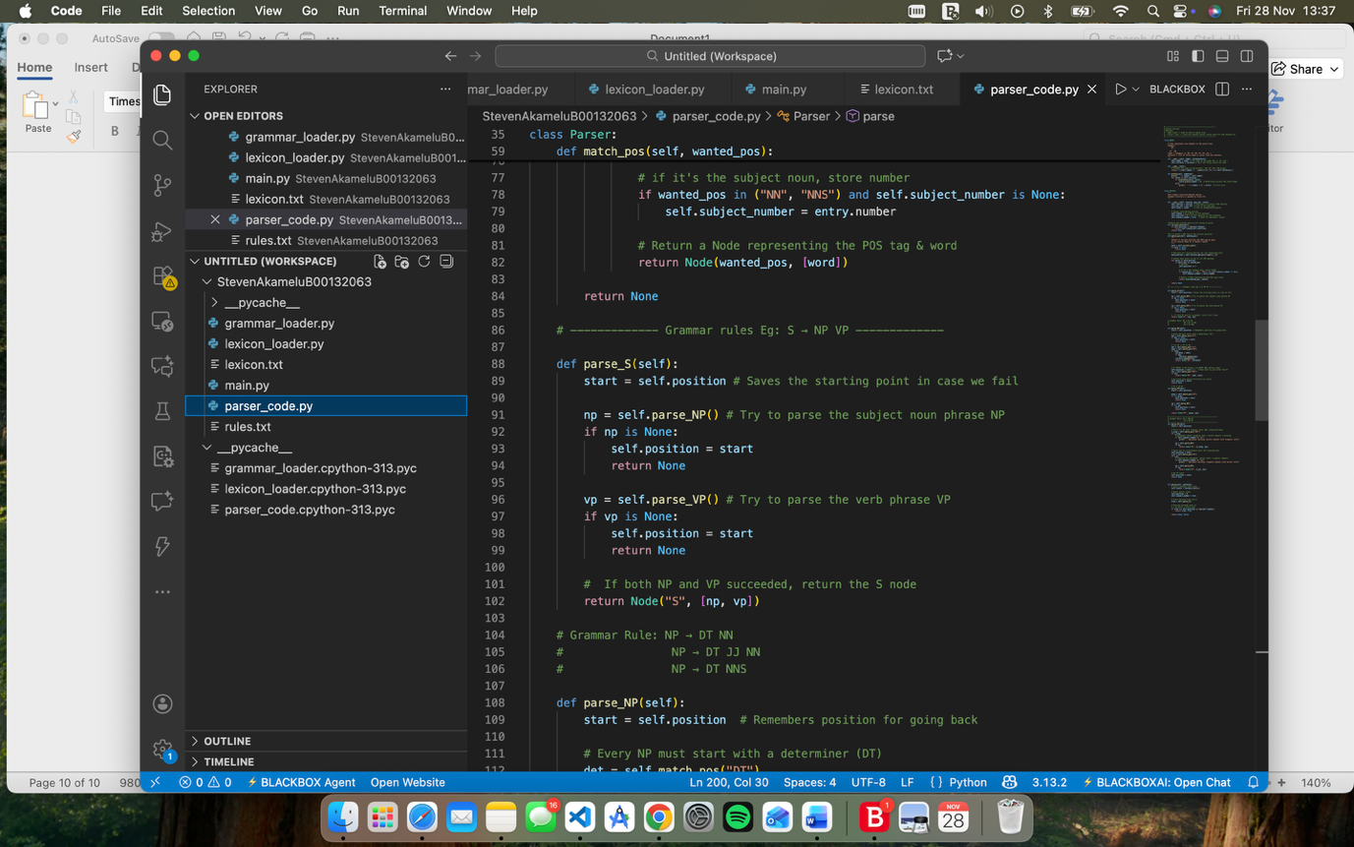

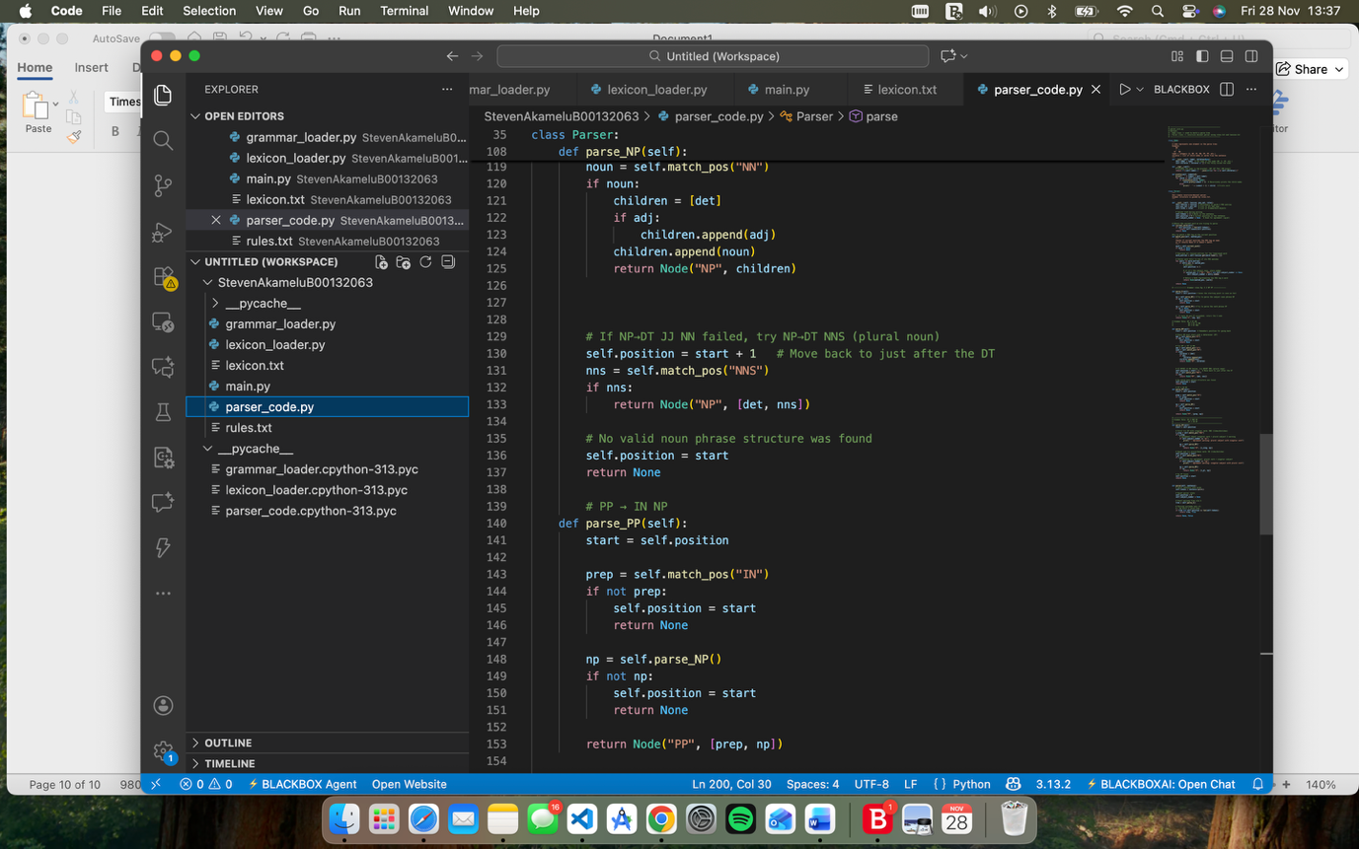

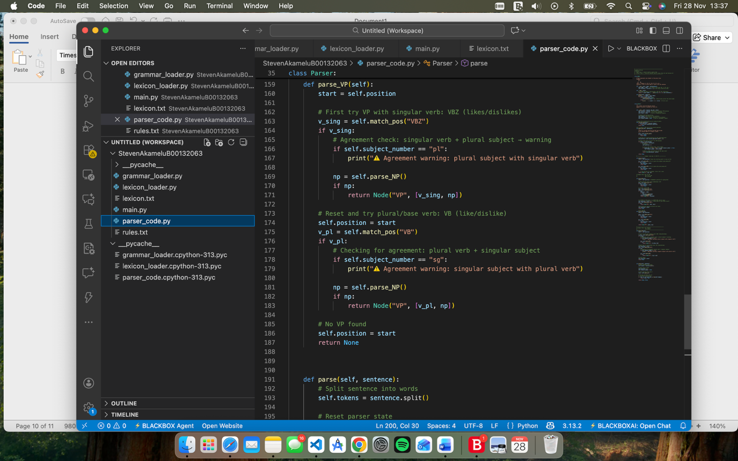

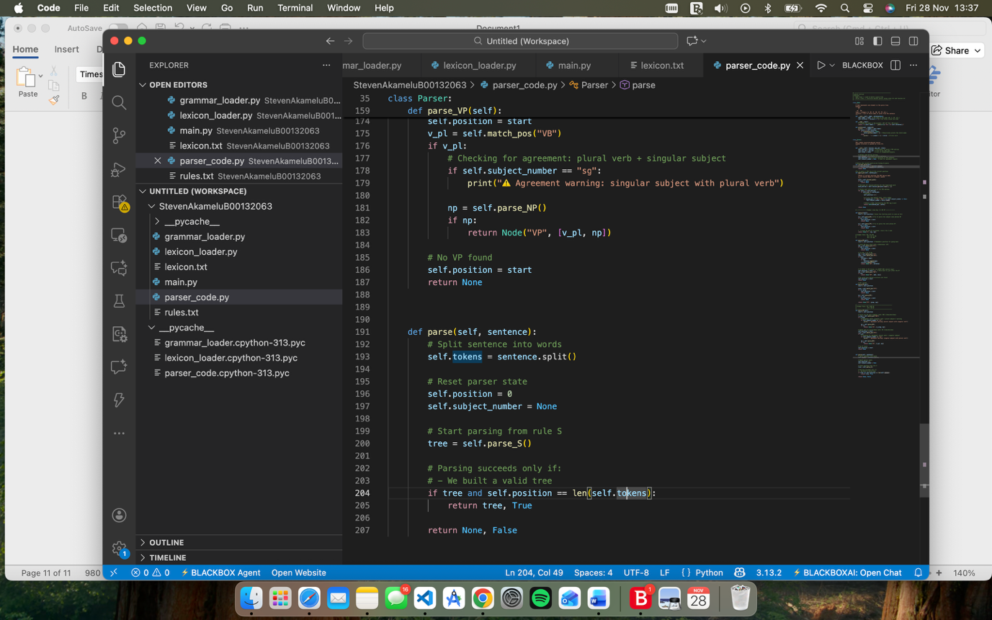

1. **Main.py:**

This is where everything is put together and called together after being loaded together.

It calls load_loader() so it can read the lexicon.txt,

then will call the load_rules() to read the rules.txt file.

Once both has been done a Parser object will be made hence this line parser = Parser(lexicon, pos_set, rules)

It shows a message to the user telling them what sentence to type out

It will then enter a loop, goes through the sentence and sees what is accepted or rejected or in need of an agreement warning.

Accepted:

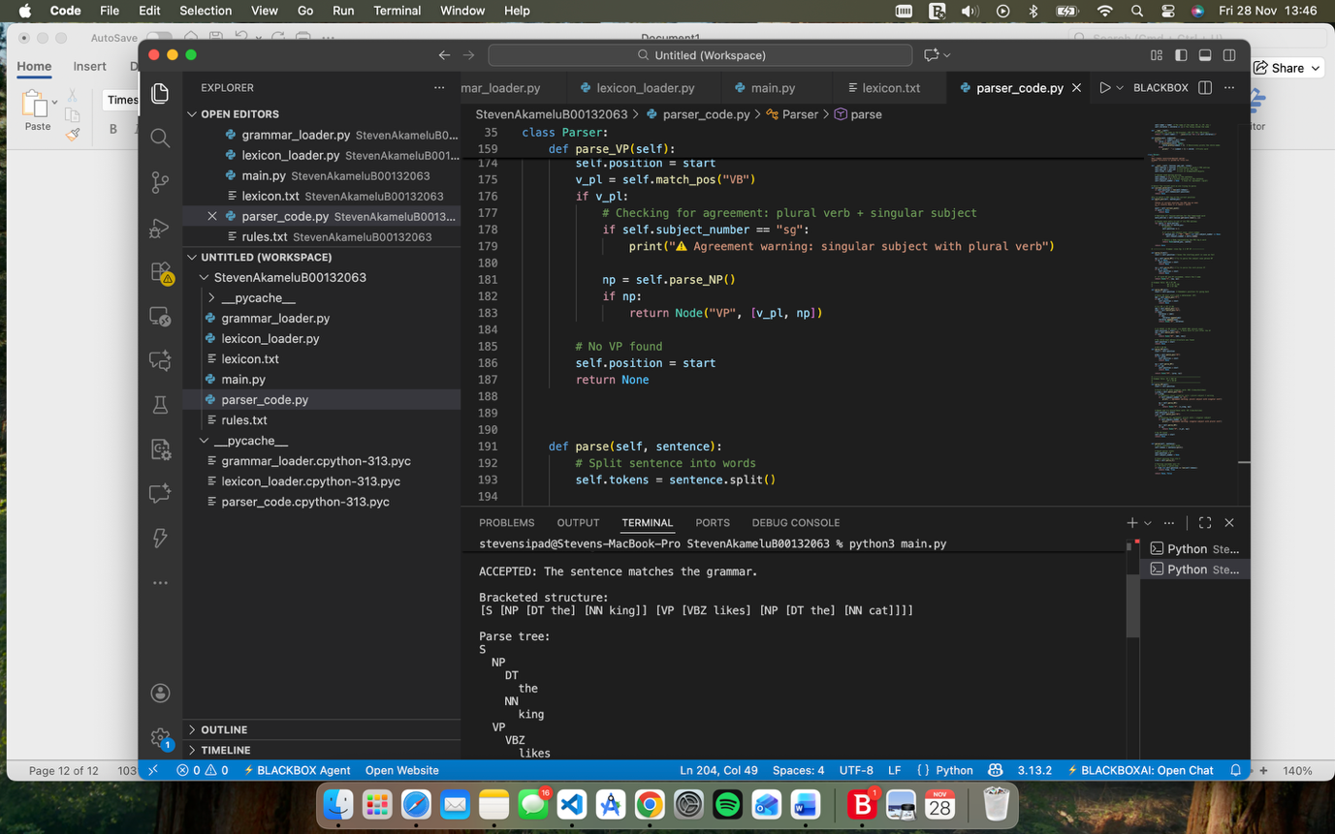

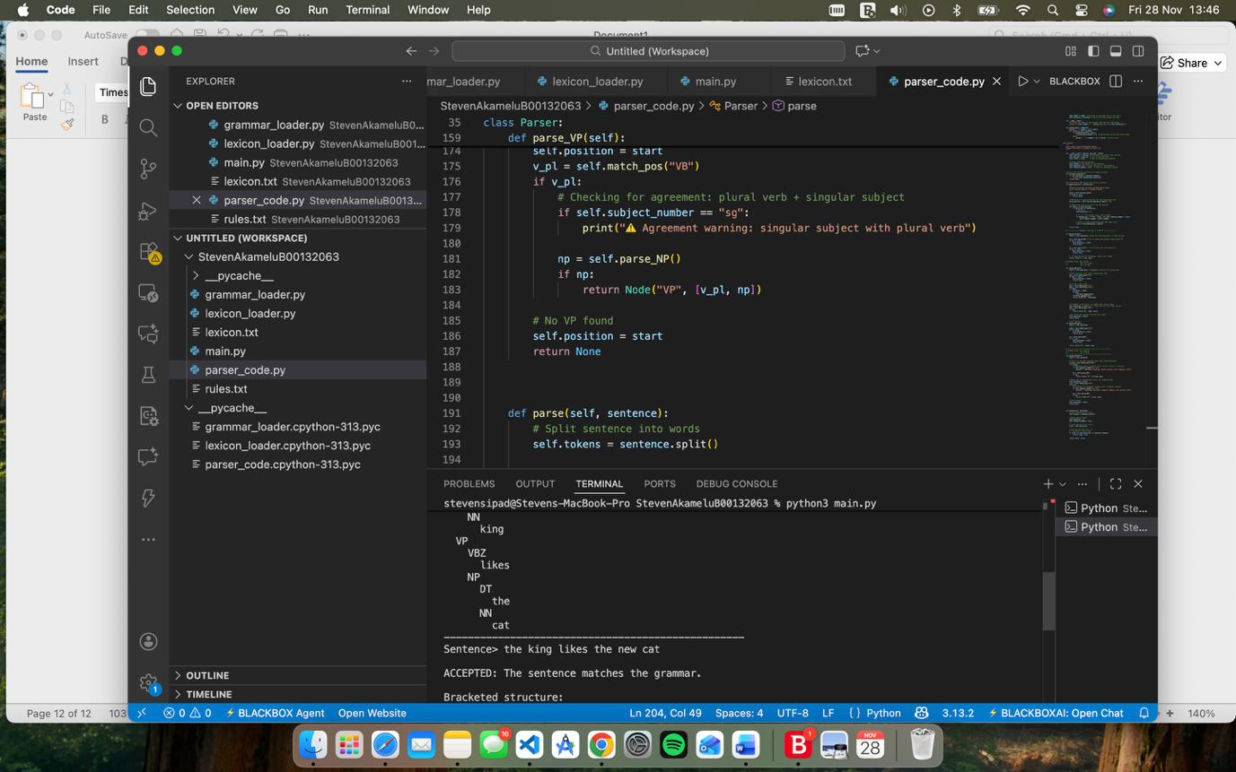

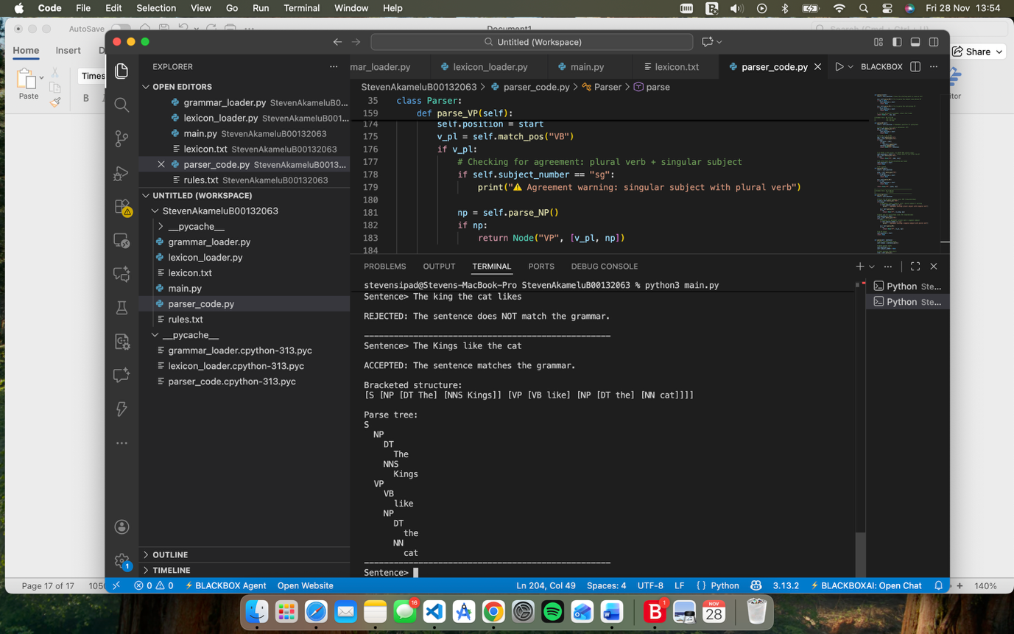

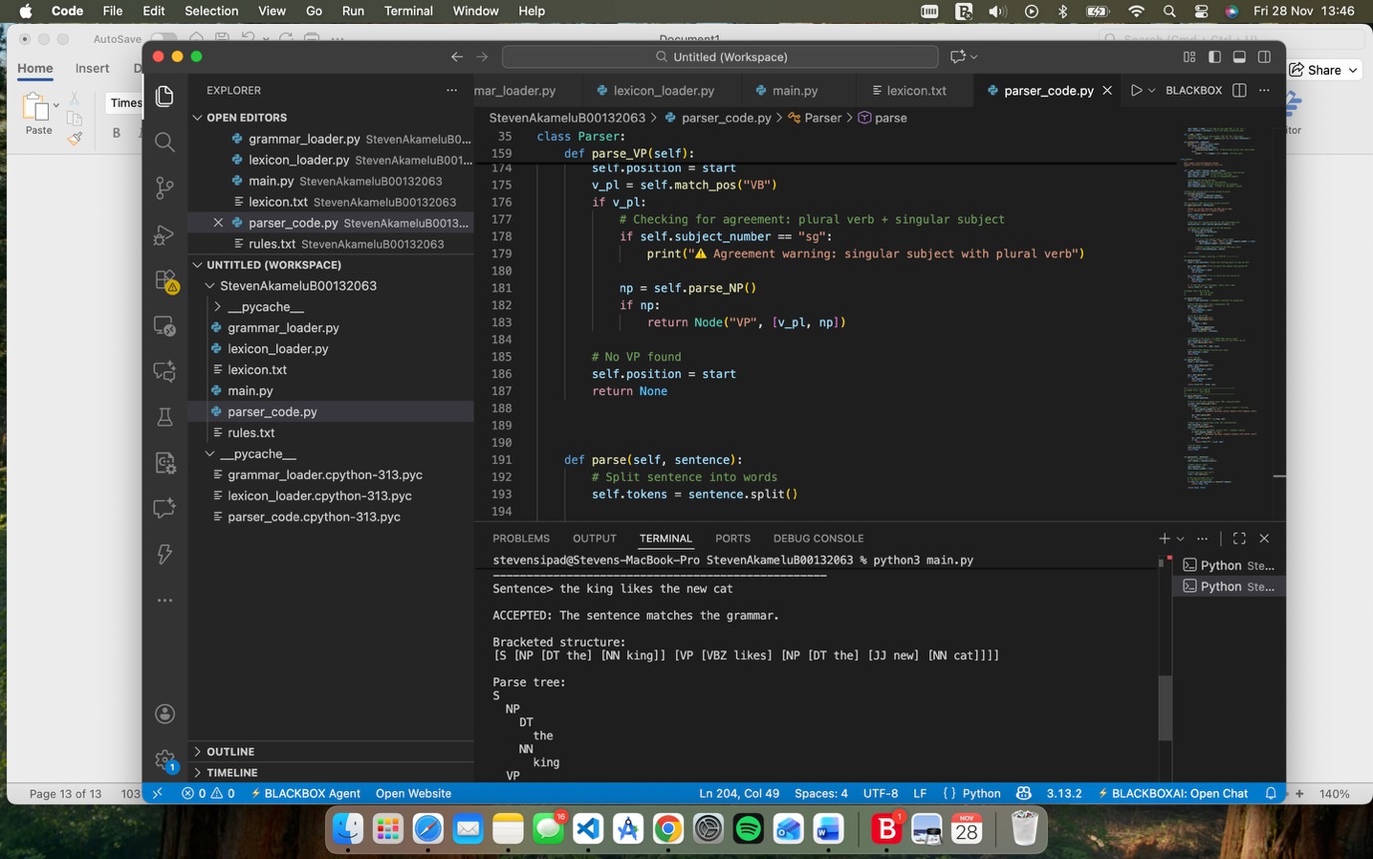

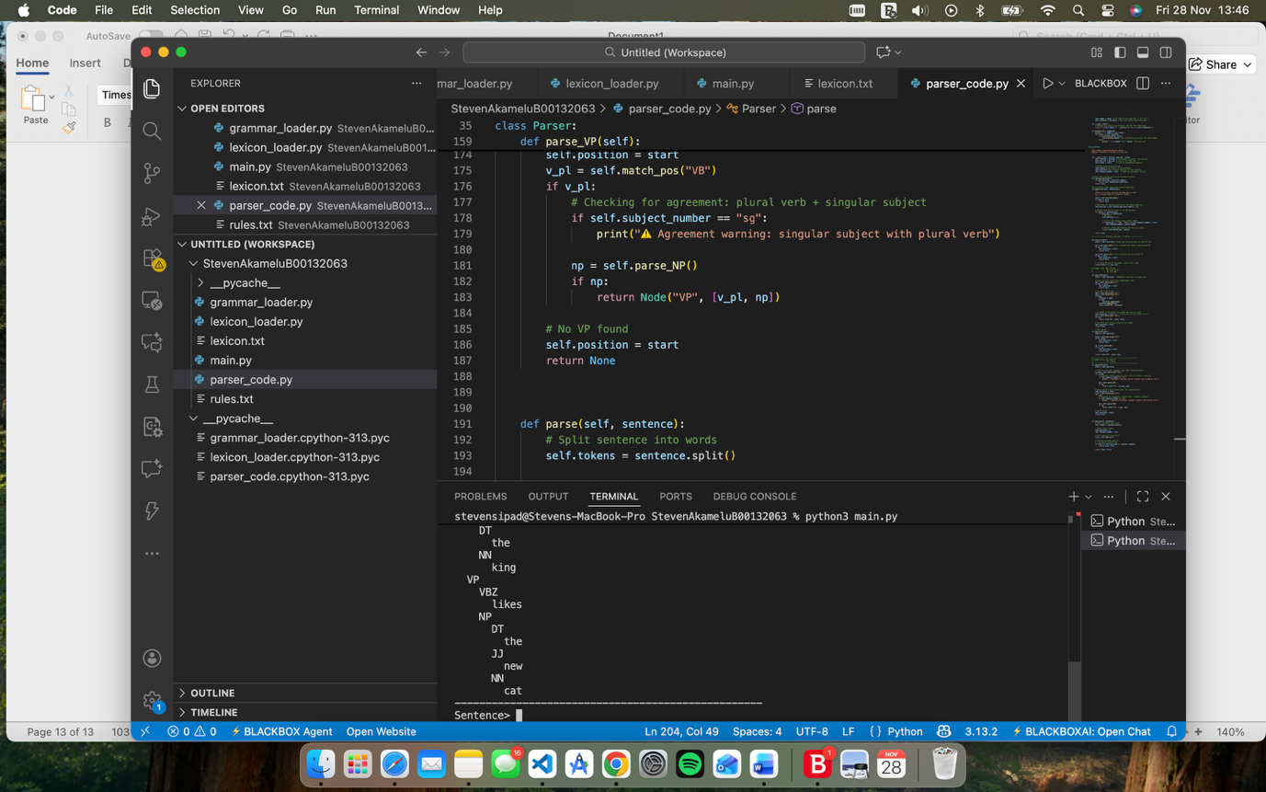

Agreement Warning:

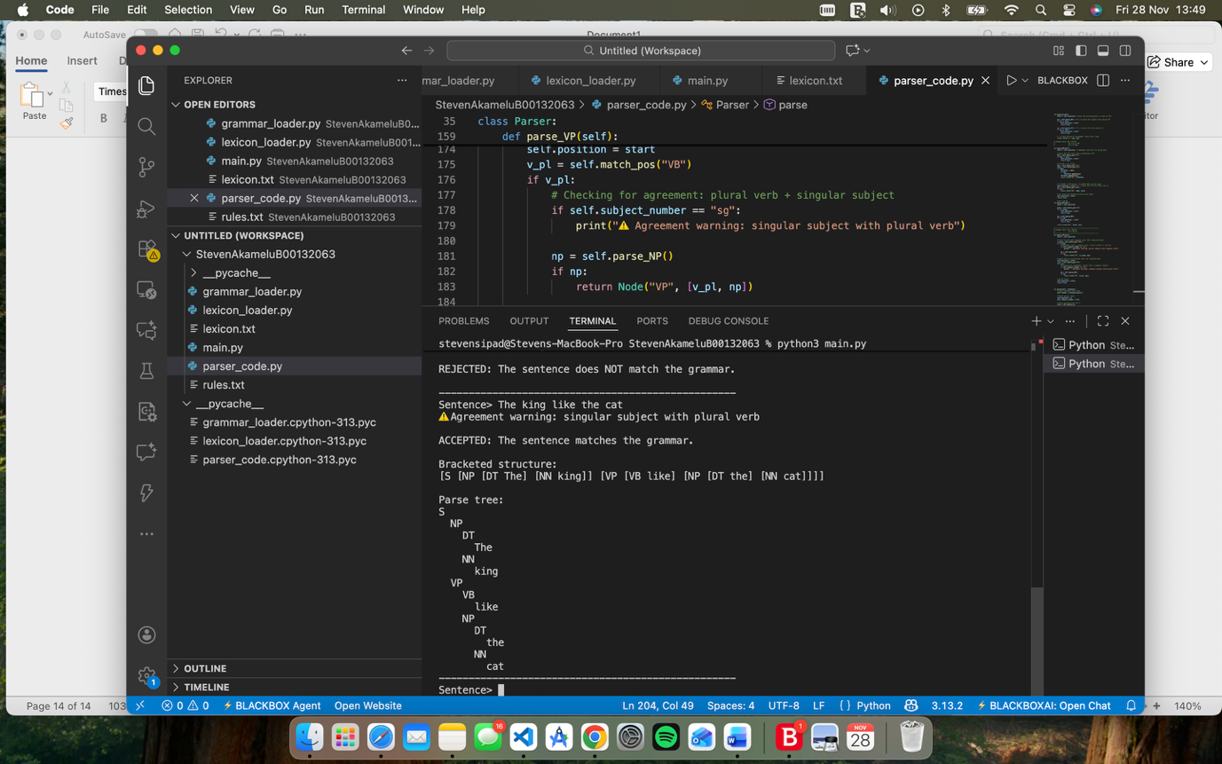

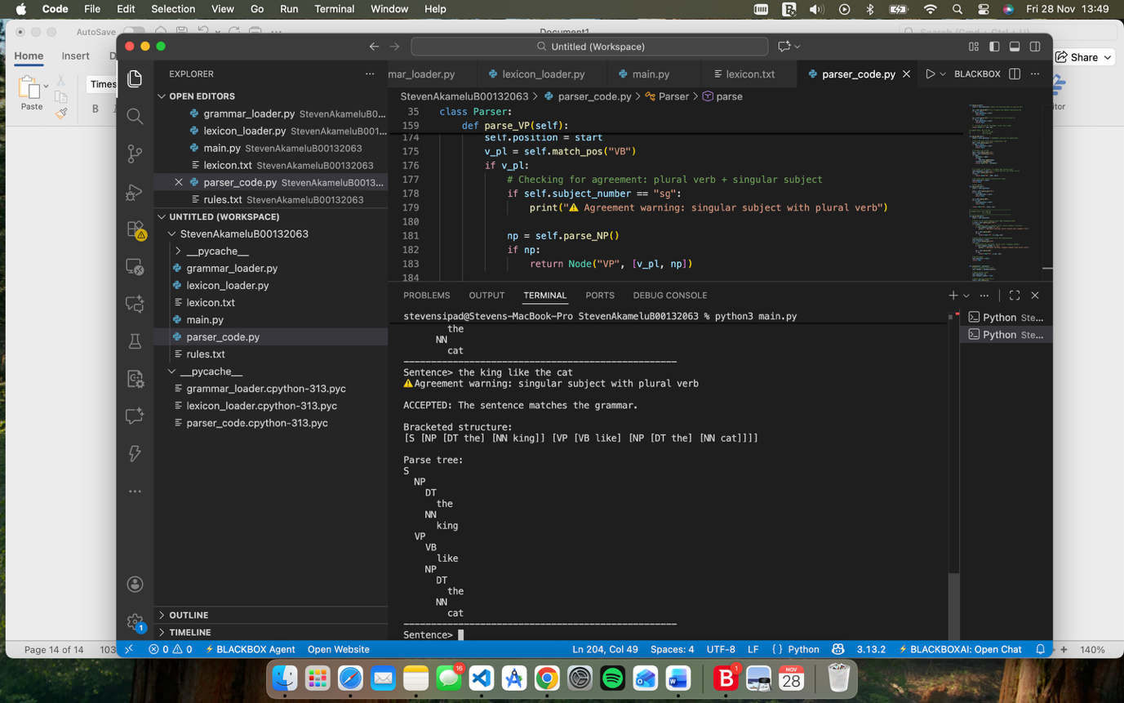

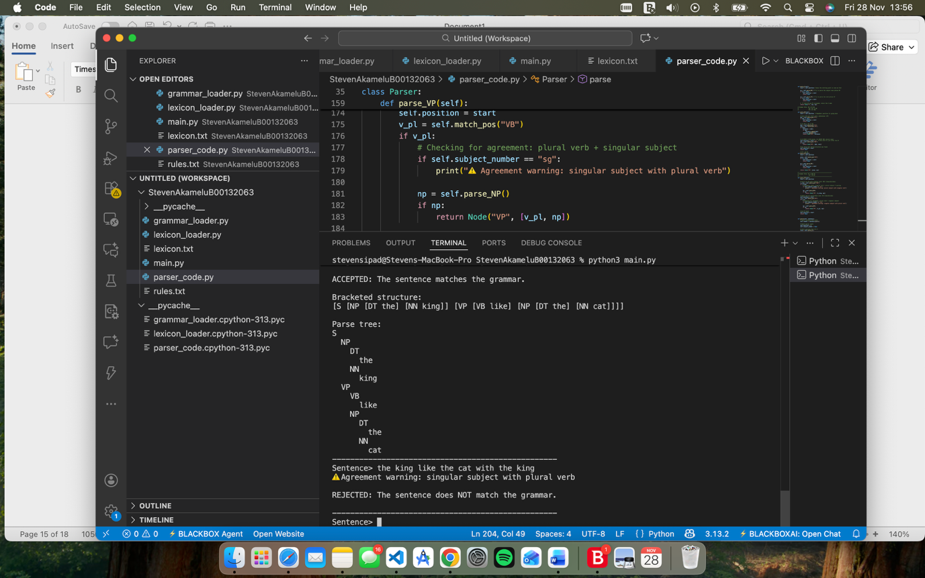

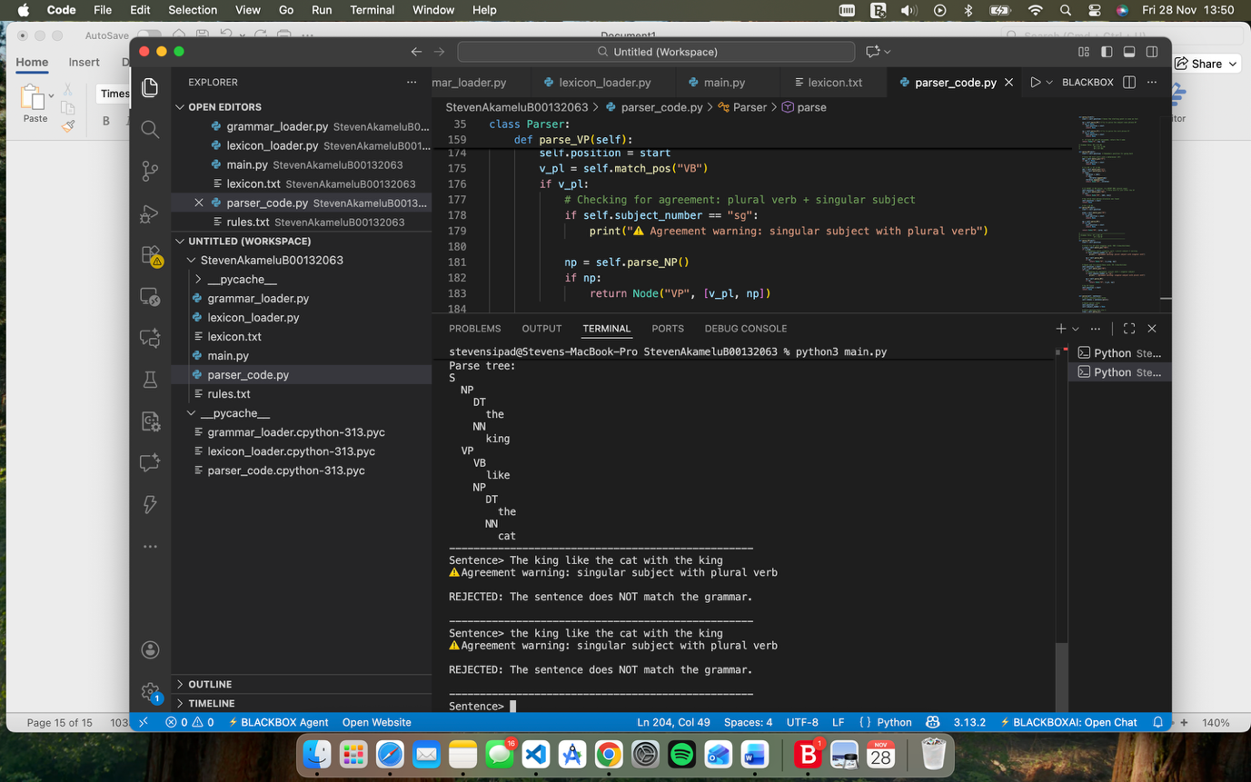

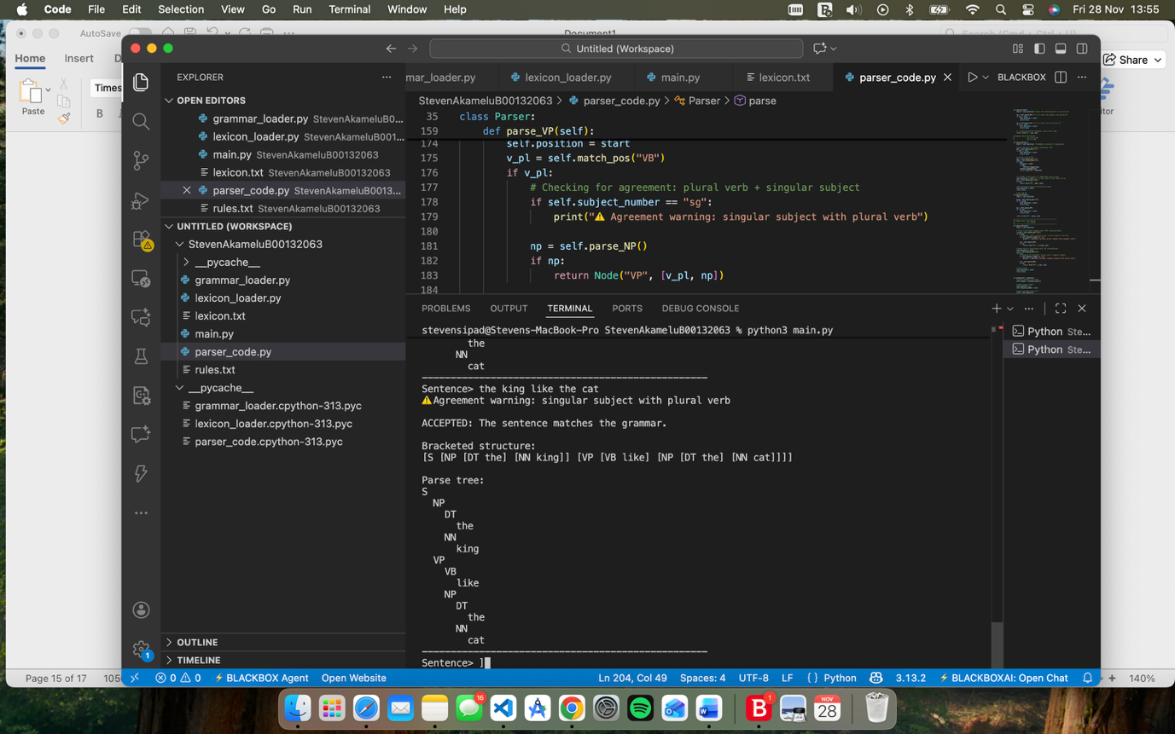

In this screenshot it shows it has a agreement warning but then also rejects the statement

Rejected:

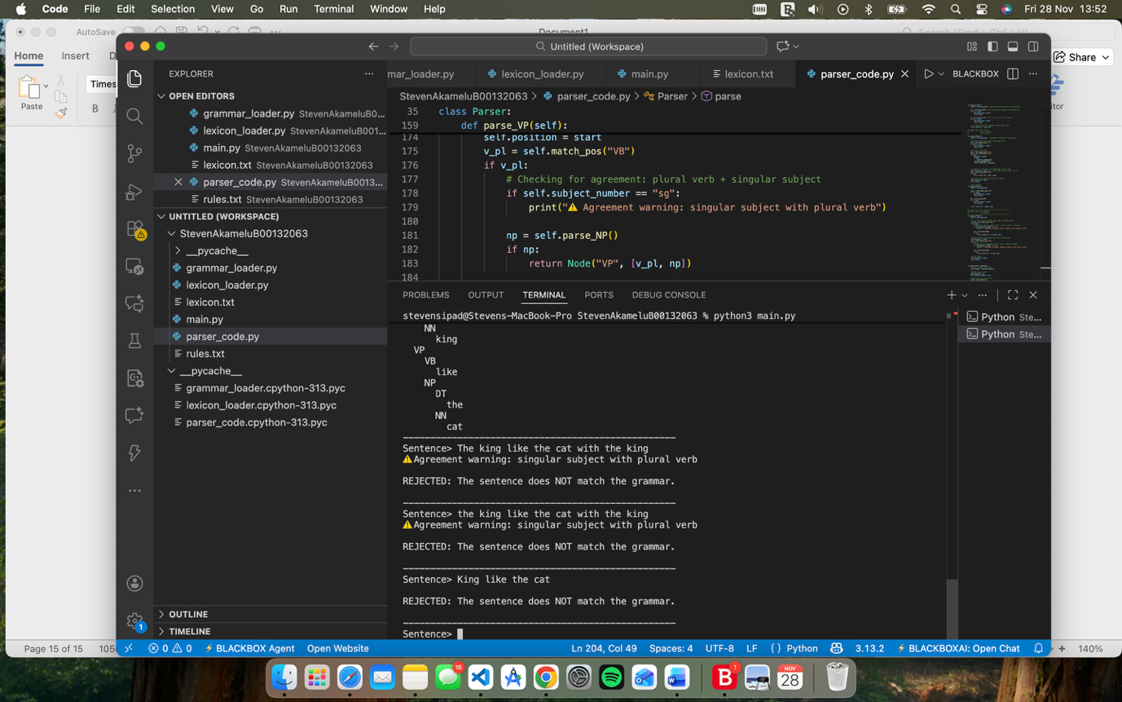

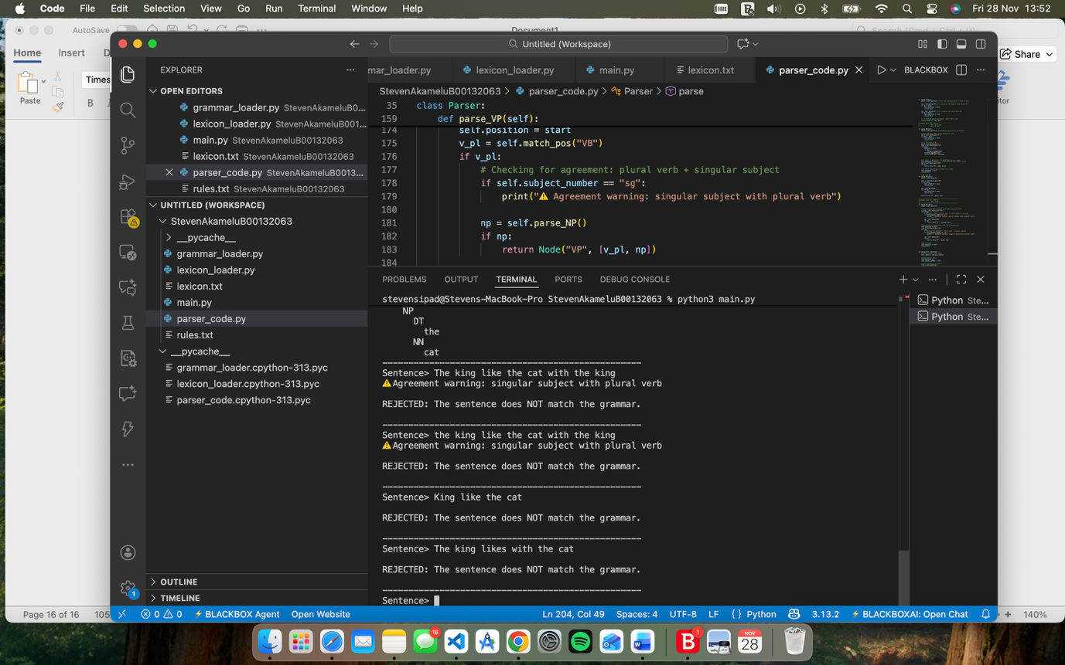

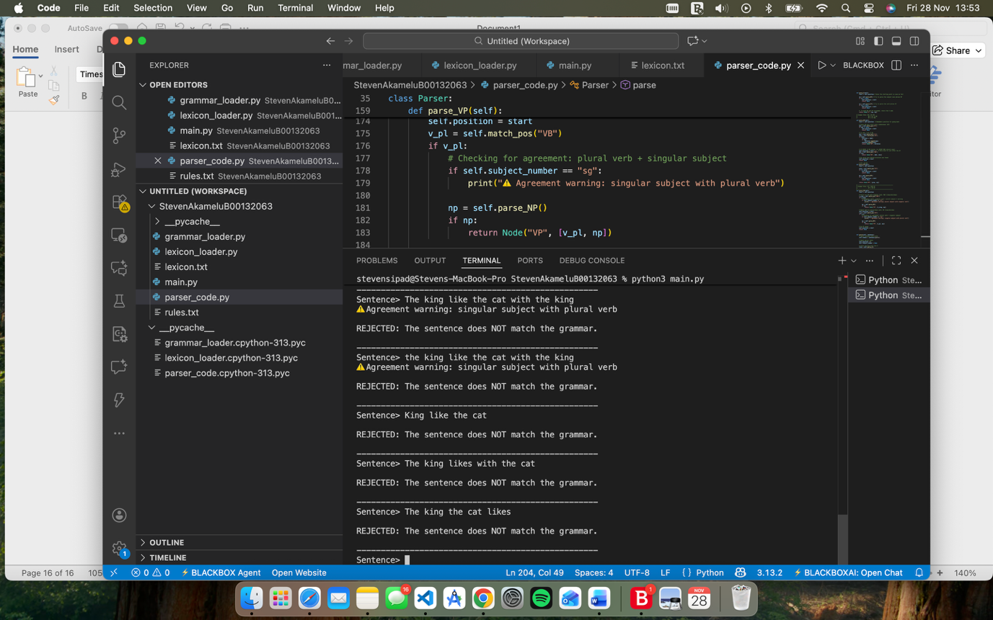

Problems I Encountered:

In my coding I had a sg. Instead of sg in my lexicon.txt so when I was trying to compile it, I couldn’t get the lexicon.txt to load into my lexicon_loader.py file once I fixed this issue it loaded successfully.

Another problem I ran into was a syntax error I had import the lexicon_loader, grammar_loader and the parser_code into my main.py but I had my parser code as parser_core.py due to that error it was trying to import a file that not only wasn’t made but also had nothing to do with the with the parser code.

I had too many inconsistent spacing in my coding which caused the error of ValueError: too many values to unpack, after carefully examining the issue I found the solution of where each line added had unnecessarily extra spacing.

My final problem I had was missing vocabulary prevented the sentence from being valid. The sentence for example was the kings dislike the new cat in the castle. While I added more to my extra features for my prepositional phrases initially it was rejected because the word castle wasn’t in my lexicon.

Overall, this project gives a practical understanding of how natural language parsers operate, how lexicons and grammars interact with parsing algorithms, and how linguistic theory can be translated into computational procedures. This system can be extended further by adding more grammatical categories with more verbs and more complex noun phrase structures in future work